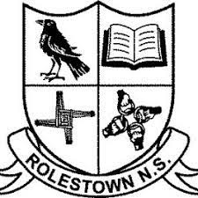
Rolestown National School

Calendar 2022/2023

School Re-opens: Wednesday 31st August 2022

Halloween Break: Monday 31st October 2022– Friday 4th November 2022 (inclusive)

Christmas Holidays: Wednesday 21st December 2022 (closing 12noon )– Wednesday 4th January 2023 (inclusive)

School Re-opens: Thursday 5th January 2023

St. Brigid’s Day: Monday 6th February 2023

Feb Mid-Term Break: Monday 13th February 2023 – Friday 17th February 2023 (inclusive)

St. Patrick’s Day: Friday 17th March 2023

Easter Holidays: Monday 3rd April 2023 – Friday 14th April 2023 (inclusive)
School Re-opens: Monday 17th April

May Bank Holiday: Monday 1st & Tuesday 2nd May 2023

June Bank Holiday: Monday 5th & Tuesday 6th June 2023

Summer Holidays: Friday 30th June 2023

