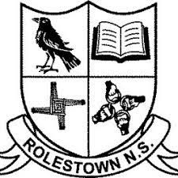
Rolestown National School

Calendar 2023/2024

School Re-opens: Thursday 31st August 2023

Halloween Break: Monday 30th October 2023– Friday 3rd November 2023(inclusive)

Christmas Holidays: Friday closing December 22nd (closing 12 noon )– Friday 5th January 2024 (inclusive)

School Re-opens: Monday 8th January 2024

St. Brigid’s Day: Monday 5th February 2024

Feb Mid-Term Break: Monday 12th February 2024 – Friday 16th February 2024 (inclusive)

St. Patrick’s Day: Monday 18th March 2024

Easter Holidays: Monday 25th March 2024 – Friday 5th April 2024 (inclusive)

School Re-opens: Monday 8th April

May Bank Holiday: Monday 6th & Tuesday 7th May 2024

June Bank Holiday: Monday 3rd June 2024

Summer Holidays: Friday 28th June 2024

